MANDATORY DISCLOSURE

(Norms: As per AICTE, New Delhi, Approval Process Handbook 2023-2024)

**Update as on February 2025**

|  |  |
| --- | --- |
| **AICTE current application ID** |  |

|  |  |
| --- | --- |
| **Name of the Institution** | NKSPT INSTITUTE OF ENGINEERING AND TECHNOLOGY  PATHRIKAR CAMPUS |
| **Address.** | Pathrikar Campus, Highway No 6, Chhatrapati Sambhajinagar – Jalna Highway, Tq. Badnapur, Dist. Jalna |
| **City with Pin code** | Badnapur 431202 |
| **District** | Jalna |
| **State/UT** | Maharashtra |
| **Nationality** | India |
| **Type of Institution** | Private–Self Financed |
| **Mobile Number** | +91 9699880950 |
| **E-mail** | ioebadnapur@gmail.com |
| **Website** | [www.nkspt.org/ioe](http://www.nkspt.org/ioe) |
| **Name and address of the Trust/ Society running the Institution** | NIRMAL KRIDA AND SAMAJ PRABODHAN TRUST |
| **Address** | Plot No. 490, N-3 Cidco, Chhatrapati Sambhajinagar |
| **City with Pin code** | Chhatrapati Sambhajinagar 431003 |
| **State/UT** | Maharashtra |
| **National** | India |
| **Type of Trust/Society** | Trust |
| **Telephone** | 02482261188 |
| **E-mail** | admin@nkspt.in |
| **Website** | [www.nkspt.org](http://www.nkspt.org) |

COLLEGE VIEW SATELLITE MAPS

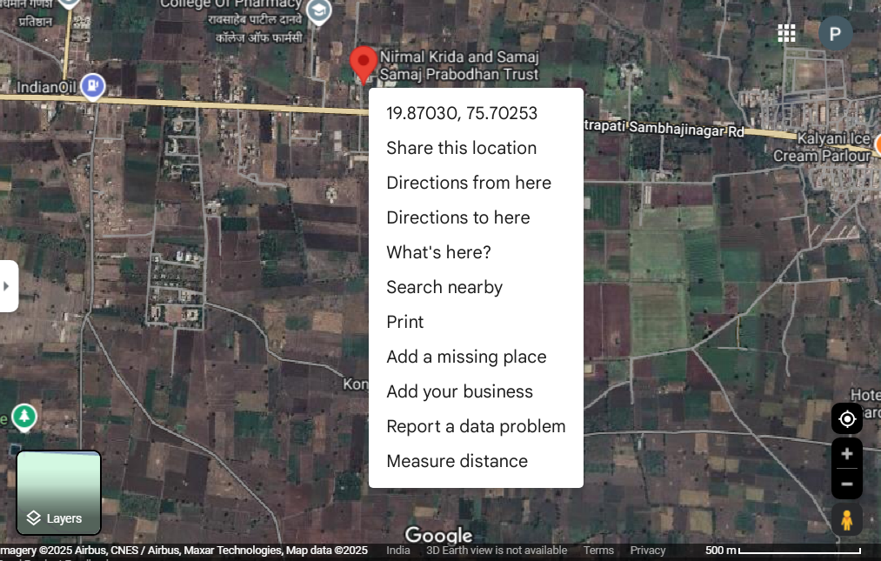

|  |  |
| --- | --- |
| **Nameof the affiliating University** | **Dr. Babasaheb Ambedkar Technological University, Lonere** |
| **Address** | Lonere, Tal-Mangaon, Dist-Raigad, Maharashtra, 402103 |
| **Telephone** | 02140 - 275142 |
| **e-mail** | registrar@dbatu.ac.in |
| **Website** | www.dbatu.ac.in. |

**Governing Body**

|  |  |  |
| --- | --- | --- |
| **Sr. No** | **Name** | **Designation** |
| 1 | Dr. Mrs. Meher D. Pathrikar | Secretary |
| 2 | Dr. Devesh D. Pathrikar | Chairman |
| 3 | Mrs. Pradnya D. Pathrikar | Member |
| 4 | Dr. S. S. Shaikh | Member |
| 5 | Dr. Nazma Khan | Member |
| 6 | Dr. Abid D. Shaikh | Principal |

**Grievance Redressal mechanisms for Faculty, staff and students**

As per Notification dated 25 May 2012 - F. No. 37-3/Lega112012, Clause 1 of Section 23 of the All India Council for Technical Education, Act, 1987 (52 of 1987) NKSPT Institute of Engineering and Technology Pathrikar Campus, Badnapur has Constituted Grievance Redressal Committee to ensure transparency and support for teaching, non teaching staff and students admitted and with paramount objective of preventing unfair practices and to provide a mechanism for fair Redressal of grievance.

|  |  |  |
| --- | --- | --- |
| Sr. No. | Name Of Members | Designation |
| 1 | Dr. Devesh D. Pathrikar | Chairman |
| 2 | Ms. Pradnya S. Sanap | Member |
| 3 | Dr. S. S. Shaikh | Member |
| 4 | Dr. Abid D. Shaikh | Member |
| 5 | Ms. Monika Evarkar | Member |

**Establishment of Anti Ragging Committee**

|  |  |  |
| --- | --- | --- |
| Sr. No. | Name Of Members | Designation |
| 1 | Dr. Devesh D. Pathrikar | Chairman |
| 2 | Ms. Pradnya S. Sanap | Member |
| 3 | Dr. S. S. Shaikh | Member |
| 4 | Dr. Abid D. Shaikh | Member |
| 5 | Ms. Anuja Deshmukh | Member |
| 6 | Ms. Ranjana Patil(Damini Pathak) – Mob: 8850445772 | Member |
| 7 | Ms. Seema Landge(API Badnapur)- Tel. 02482-261033 | Member |
| 8 | Student Representative | Member |
| 9 | Student Representative | Member |

Establishment of Online Grievance Redressal Mechanism

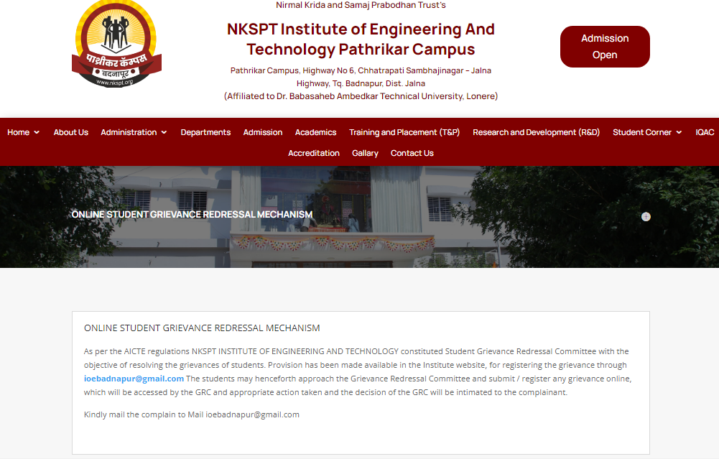

Establishment of Internal Complaint Committee (ICC)

|  |  |  |
| --- | --- | --- |
| Sr. No. | Name | Designation |
| 1. | Dr. Devesh D. Pathrikar | Chairman |
| 2. | Ms. Pradnya S. Sanap | Member |
| 3. | Dr. S. S. Shaikh | Member |
| 4. | Dr. Abid D. Shaikh | Member |
| 5. | Ms. Anuja Deshmukh | Member |

Establishment of Committee for SC/ST

|  |  |  |
| --- | --- | --- |
| Sr. No. | Name Of Members | Designation |
| 1 | Dr. Shaikh Abid D. (Director) | Chairman |
| 2 | Ms. Sanap Pradnya S. | Member |
| 3 | Mr. Bhoite Ganesh K. | Member |
| 4 | Mr. Raza Khan | Member |
| 5 | Ms. Deshmukh Nishigandha P. | Member |

Programmes

|  |  |  |  |  |
| --- | --- | --- | --- | --- |
| **Sr. No** | **Name of Programmes** | **Intake** | **Level** | **Duration** |
| 1 | Computer Science And Engineering | 120 | UG | 4 Yrs |
| 2 | Information Technology | 60 | UG | 4 Yrs |
| 3 | Electronics And Telecommunication | 60 | UG | 4 Yrs |
| 4 | Artificial Intelligence And Data Science | 60 | UG | 4 Yrs |

Faculty Student Ratio

|  |  |
| --- | --- |
| Faculty: Student Ratio | 01:20 |

Admission

Number of seats sanctioned with the year of approval

|  |  |  |  |
| --- | --- | --- | --- |
| **Sr. No** | **Name of Programmes approved by AICTE** | **INTAKE** | **LEVEL** |
| 1 | Computer Science And Engineering | 120 | UG |
| 2 | Information Technology | 60 | UG |
| 3 | Electronics And Telecommunication | 60 | UG |
| 4 | Artificial Intelligence And Data Science | 60 | UG |

Admission Procedure

|  |  |
| --- | --- |
| Mention the admission test being followed, name and address of the Test Agency and its URL (website) | 1) MH-CET: Entrance test conducted by State Common Entrance Test Cell, Maharashtra State Mumbai (Website –[www.mahacet.org](http://www.mahacet.org/) ) |
| 2) AIEEE:-- |
| 3) JEE Main: Central Board of Secondary Education ,New Delhi. |
| 4) JEE Advance: Central Board of Secondary Education, New Delhi. |
| Number of seats allotted to different Test Qualified candidate separately (AIEEE/CET (State conducted test University tests /CMAT / GPAT)  Association conducted test) | 1)MH-CET:65% of sanctioned intake of each course |
| 2)AIEEE,JEE Main & JEE Advance:15% of sanctioned intake of  each course |
| 3)Institute level seats:20% of sanctioned intake of each course |

Criteria and Weight ages for Admission

Describe each criterion with its respective weight ages i.e. Admission Test, marks in qualifying examination etc.

1. CAP admission : Candidate should be an Indian National and should have passed the HSC (Std.XII) examination of Maharashtra State Board of Secondary and Higher Secondary Education or its equivalent examination with subjects English, Physics, Chemistry and Mathematics and Secured Minimum 150 marks out of 300 marks (minimum 45% marks i.e. 135 marks out of 300 marks in case of candidates of Backward class categories belonging to Maharashtra state only) in the PCM added together and Obtained non – Zero Score in Physics, Chemistry and Mathematics at MH– CET/AIEEE.
2. Institute level and vacant seat admission: Candidate should be an Indian National and should have passed the HSC(Std.XII) examination of Maharashtra State Board of Secondary and Higher Secondary Education or its equivalent examination with subjects English, Physics, Chemistry and Mathematics and Secured Minimum 150 marks out of 300 marks (minimum 45%marks i.e.135 marks out of 300 marks in case of candidates of Backward class categories belonging to Maharashtra state only) in the PCM added together and Obtained non –Zero Score in Physics, Chemistry and Mathematics at MH– CET/AIEEE.
3. Candidate should be an Indian National and should have passed the HSC (Std.XII) examination of Maharashtra State Board of Secondary and Higher Secondary Education or its equivalent examination with subjects English, Physics, Chemistry and Mathematics and Secured Minimum 150 marks out of 300 marks (minimum 45% marks i.e. 135 marks out of 300 marks in case of candidates of Backward class categories belonging to Maharashtra state only) in the PCM added together. Mention the minimum level of acceptance, if any Candidate should be an Indian National and should have passed the HSC(Std.XII) examination of Maharashtra State Board of Secondary and Higher Secondary Education or its equivalent examination with subjects English, Physics, Chemistry and Mathematics and Secured Minimum150 marks out of 300 marks (minimum 45% marks i.e. 135 marks out of 300 marks in case of candidates of Backward class categories belonging to Maharashtra state only) In the PCM added together and Obtained non–Zero Score in Physics, Chemistry and Mathematics at MH – CET/AIEEE.